Ideation Phase
Define the Problem Statements

Date | 31 January 2026
Team ID | LTVIP2026TMIDS82987
Project Name | Strategic Product Placement Analysis: Unveiling Sales Impact with Tableau Visualization
Maximum Marks | 2 Marks

Customer Problem Statements:

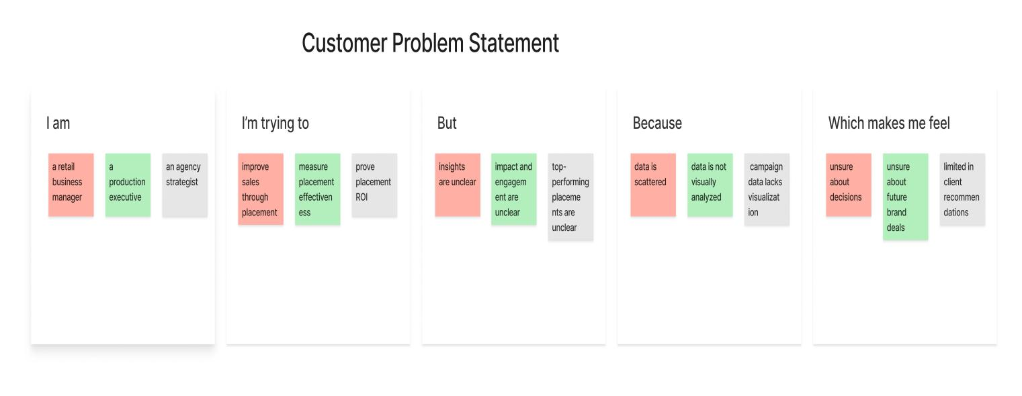

PS–1: Retail & Consumer Goods Perspective
I am a retail business manager
I’m trying to understand how product positioning within stores and digital platforms impacts sales performance and customer purchasing behavior
But I lack clear, visual insights into which product placements drive higher visibility and conversions
Because sales data, placement details, and customer demographics are scattered and difficult to interpret together
Which makes me feel uncertain about how to optimize product placement strategies to increase revenue and customer engagement

PS–2: Film & Television Production Companies
I am a film or television production executive
I’m trying to evaluate the effectiveness of product placements within scenes and episodes
But I cannot clearly measure audience engagement or the revenue impact of different placement strategies
Because there is no visual, data-driven way to analyze placement performance across content and brands
Which makes me feel challenged when negotiating brand partnerships and planning future placement opportunities

PS–3: Advertising Agencies
I am an advertising agency strategist
I’m trying to demonstrate the ROI of product placement campaigns across various media channels
But I struggle to present clear insights on which placements perform best
Because campaign data is complex and lacks intuitive visualization
Which makes me feel limited in optimizing campaigns and delivering strong, data-backed recommendations to clients

